**SCRUM AND AGILE METHODOLOGIES FOR DEVELOPMENT**

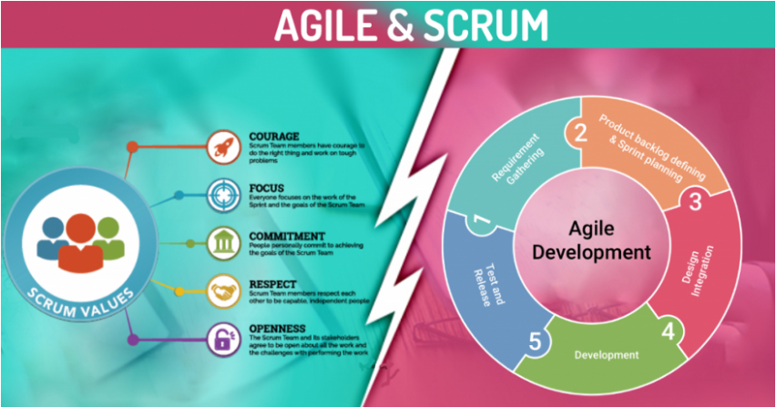

*Source:medium.com*

Scrum concepts and practices in the workforce can dramatically growth performance and in the end result in higher results, higher merchandise and better price for clients and the organization.

**What Is Agile Methodology?**

Agile method is a practice that facilitates non-stop new release of improvement and trying out withinside the SDLC process. Agile breaks the product into smaller builds.

In this method, improvement and trying out activities are concurrent, in contrast to different software program improvement methodologies. It additionally encourages teamwork and face-to-face communication. Business, stakeholders, and builders and customers have to paintings collectively to broaden a product.

**What is Scrum?**

Scrum is an agile project control method or framework used commonly for software program development tasks with the intention of handing over new software program functionality each 2-four weeks. It is one of the techniques that inspired the Agile Manifesto, which articulates a fixed of values and concepts to manual selections on a way to broaden better-fine software program faster.

**The 4 values of the Agile Manifesto**  
The Agile Manifesto includes 4 key values:

• Individuals and interactions over methods and tools.  
• Working software program over complete documentation.  
• Customer collaboration over settlement negotiation.  
• Responding to alternate over following a plan.

**12 Principles behind the Agile Manifesto:**

1. Satisfy the customer through early and continuous delivery of valuable software.
2. **Accommodate changing requirements throughout the development process .**Agile processes harness change for the customer’s competitive advantage.
3. Deliver working software frequently, from a couple of weeks to a couple of months, with a preference to the shorter timescale.
4. Business people and developers must work together daily throughout the project.
5. Motivated teams are more likely to deliver their best work than unhappy teams.Give them the environment and support they need, and trust them to get the job done.
6. The most efficient and effective method of conveying information to and within a development team is face-to-face conversation.
7. Working software is the primary measure of progress.
8. Teams establish a repeatable and maintainable speed at which they can deliver working software, and they repeat it with each release.
9. Continuous attention to technical excellence and good design enhances agility.

10. **Simplicity** – Develop just enough to get the job done for right now.

11. **Self-organizing teams encourage great architectures, requirements, and designs**

12.At regular intervals, the team reflects on how to become more effective, then tunes and adjusts its behavior accordingly.

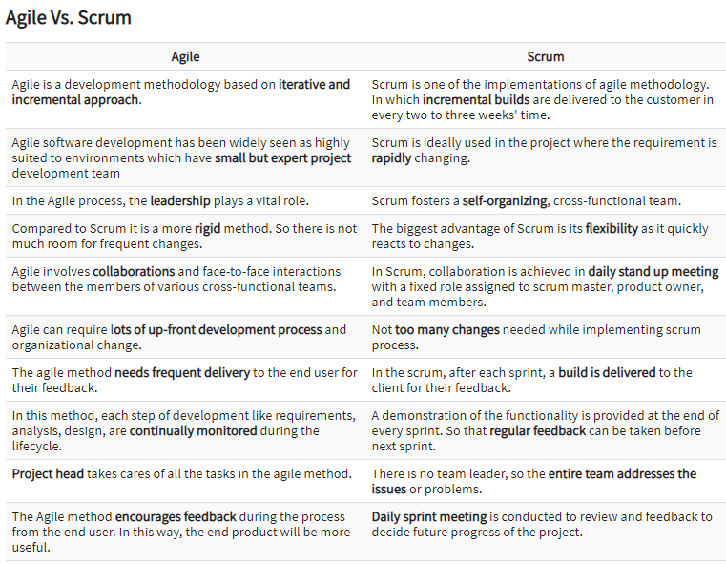

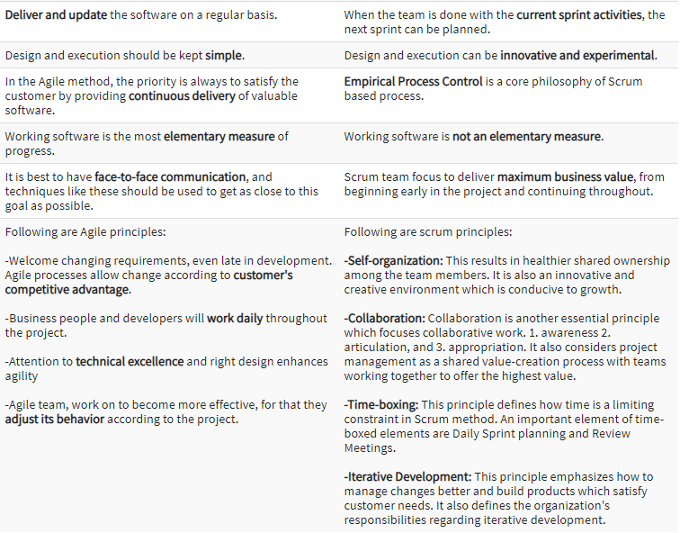

*Image source:* <https://www.guru99.com/agile-vs-scrum.html#:~:text=Agile%20is%20a%20development%20methodology,two%20to%20three%20weeks'%20time.&text=Scrum%20is%20ideally%20used%20in,the%20requirement%20is%20rapidly%20changing.>